**ARTIFICIAL INTELLIGENCE**

Natural Disasters Intensity Analysis&

Classification Using AI

|  |  |
| --- | --- |
| Date | 15.10.2022 |
| Team Id | PNT2022TMID45294 |
| Project Name | Natural Disaster Intensity Analysis & Classification Using AI |

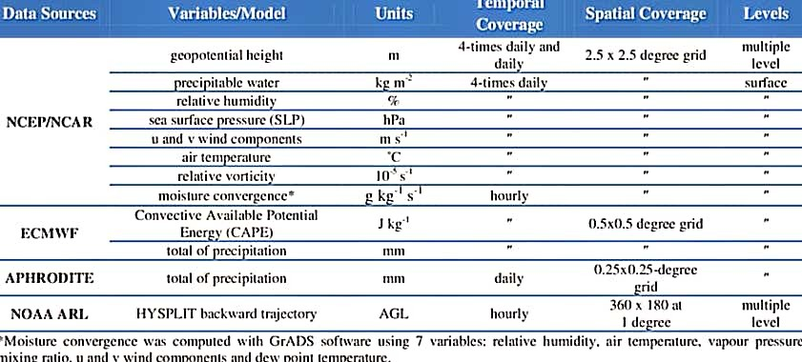 **CYLONE**

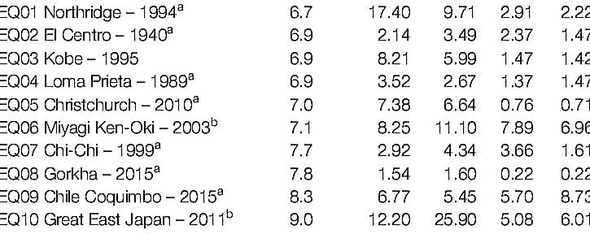**EARTH QUAKE**